Section A – Multiple Choice Questions(40 marks)
Answer ALL questions. Each question carries 2 marks.
These questions are based on material from quizzes which are based on the slides.
In each case, select one option.
Question 1. Which statement best describes a mutator (setter) method?
- It only prints information.
- It always returns a value.
- It changes the value of a field.
- It creates a new object.

Question 2. What is the effect of System.out.println("# " + price + " cents.");
- Prints only the variable name.
- Adds price to a balance field.
- Concatenates the string and the value of price into output.
- Returns the value.

Question 3. Which list correctly names the three kinds of variables discussed in class design?
- Locals, packages, and modules
- Fields, arrays, and constants
- Parameters, methods, and classes
- Fields, parameters, and local variables

Question 4. What does the statement balance = balance + amount; do?
- Always resets balance to zero.
- Creates a new variable.
- Adds amount to the current value of balance.
- Swaps two values.

Question 5. What is wrong with the declaration Int number = 5;
- Value cannot be assigned at declaration
- Data type is case-sensitive
- Semicolon is missing
- Variable name is invalid

Question 6. In the method below, what value is returned?
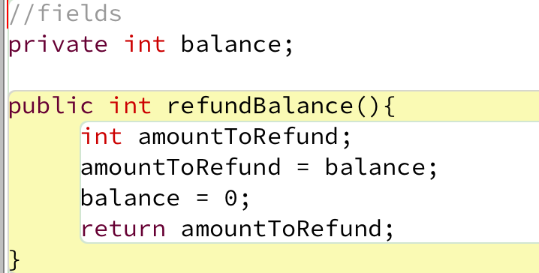

- The new value of balance
- Nothing is returned
- 0
- The old value of balance

Question 7. In Java, a ________is a small, meaningful piece of code such as a keyword, operator, literal, or identifier.
- token
- block
- method
- comment
Question 8. The scope of a field is:
- The whole class
- The block in which it is declared
- Limited to a single statement
- Only inside its method

Question 9. What does this statement do?:
x += 5;
- Multiplies x by 5
- Sets x to 5
- Divides x by 5
- Increases x by 5

Question 10. Given int a = 7, b = 2; what is the value of:
a / b
- 4
- Error
c. 3.5
d. 3.

Question 11. What is the final value of x after this executes (assume int x = 4;)?
x -= 6; // line 1
x += 3; // line 2
- -2
- -3
- 1
- 7

Question 12. What is wrong with this code?

if (x = 5) {
System.out.println("Five");
}
- Nothing is wrong
- Missing semicolon after if
- Should use === in Java
- Uses = instead of ==

Question 13. For input mark, when is this condition true?
(mark >= 0) && (mark <= 100)
- When mark is between 0 and 100 inclusive
- When mark is negative
- Always
- Only when mark is strictly between 0 and 100

Question 14. Which are valid Java boolean literals? Select one:
- true and false
- 1 and 0
- Yes and No
- "true" and "false"

Question 15 Java, which of these is not a type of loop?
- for
- do while
- while
- repeat until

Question 16 . What is the main purpose of using a loop in programming?
- To execute a set of statements only once
- To repeat a set of statements multiple times
- To compare two numbers
- To define a variable
Question 17. Which of the following for loop headers would create an infinite loop?
- for (int i = 0; i < 5; i++)
- for (int i = 1; i <= 10; i++)
- for (int i = 10; i > 0; i--)
- for ( ; ; )

Question 18. In a Person array, what does friends[i].printFirstName() do?
- Causes a compile error
- Accesses an element without printing anything
- Calls the printFirstName90 method on the Person object stored at index i
- Creates a new Person

Question 19. In Java, how do you declare an array of 10 integers?
- int numbers = new int(10);
- int[] numbers = new int[10];
- numbers = new int[10];
- int numbers = [10];

Question 20. Which of the following is a valid declaration for an array of String objects?
- String[] words = new String[4];
- String words = new String(4);
- Both B and C
- String words[] = {"Dog", "Cat"};

